**Kol Simcha Torah Gazette**

**For parshas ha’azinu &**

**Succos-simchas torah 5786**

Vol 10 Issue 3 (Whole #467) 12 Tishrei 5785/ October 4

& 15-23 Tishrei/October 7-15, 2025

**Printed L’illuy nishmas Nechama bas R’ Noach, a”h**

For a free subscription, please forward your request to [***keren18@juno.com***](mailto:keren18@juno.com)

***Past emails can be found on the website ShabbosStories.com under Brooklyn Torah Gazette***

**How To Celebrate Sukkot 5786**

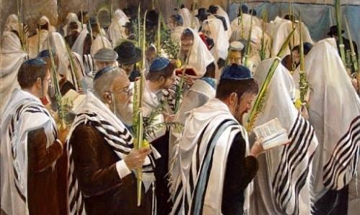

**Jews circling the bimah on Sukkot. Credit: Alex Levin**

[**Sukkot**](https://www.chabad.org/library/article_cdo/aid/4126/jewish/Sukkot-2025.htm) 2025 ([**October 6-13, 2025**](https://www.chabad.org/calendar/zmanim.asp?hdate=7/15))

Sukkot is a weeklong Jewish holiday that comes five days after Yom Kippur. Sukkot celebrates the gathering of the harvest and commemorates the miraculous protection G‑d provided for the children of Israel when they left Egypt. We celebrate Sukkot by dwelling in a foliage-covered booth (known as a [*sukkah*](https://www.chabad.org/library/article_cdo/aid/609535/jewish/What-Is-a-Sukkah.htm)) and by taking together the [“Four Kinds”](https://www.chabad.org/library/article_cdo/aid/609564/jewish/The-Lulav-and-Etrog-The-Four-Kinds.htm) (*arba minim*), four special species of vegetation.

[**The first two days**](https://www.chabad.org/calendar/candlelighting.asp?hDate=7/14&weeks=4) (sundown on October 6 until nightfall on October 8 in 2025, and only until nightfall on Oct. 7 in Israel) of the holiday are [*yom tov*](https://www.chabad.org/holidays/JewishNewYear/template_cdo/aid/708530/jewish/Laws-of-Yom-Tov.htm), when work is forbidden, candles are lit in the evening, and festive meals are preceded by [Kiddush](https://www.chabad.org/library/article_cdo/aid/610626/jewish/Kiddush.htm) and include challah dipped in honey.

The intermediate days (nightfall on October 8 until sundown on October 13 in 2025) are quasi holidays, known as [Chol Hamoed](https://www.chabad.org/holidays/JewishNewYear/template_cdo/aid/1000452/jewish/Chol-Hamoed.htm). We dwell in the [*sukkah*](https://www.chabad.org/library/article_cdo/aid/420823/jewish/How-to-Build-a-Sukkah.htm) and take the Four Kinds every day of Sukkot (except for Shabbat, when we do not take the Four Kinds).

[**The final two days**](https://www.chabad.org/calendar/candlelighting.asp?hDate=7/21&weeks=4) (in 2025, from sundown on October 13 until nightfall on October 15, only Oct. 14 in Israel) are a separate holiday: [Shemini Atzeret / Simchat Torah](https://www.chabad.org/library/article_cdo/aid/4689/jewish/Shemini-Atzeret-Simchat-Torah-2025.htm).

**Dwelling in the Sukkah**

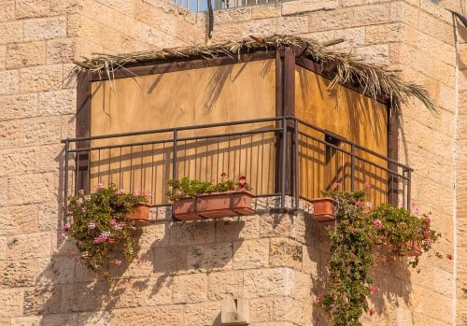

**A sukkah on an outdoor balcony.**

For seven days and nights, we eat all our [meals in the *sukkah*](https://www.chabad.org/holidays/JewishNewYear/template_cdo/aid/999940/jewish/The-Sukkah.htm) and otherwise regard it as our home. Located under the open sky, the *sukkah* is made up of at least three walls and a roof of unprocessed natural vegetation—often bamboo (sometimes in the form of convenient bamboo rolls), pine boughs or palm branches.

You can either [purchase a prefabricated *sukkah*](https://www.chabad.org/article.asp?AID=2483907) or build one on your own. Here are some basic rules to be aware of:

Is there a roof or tree over your intended *sukkah* location? The answer needs to be “no” for the *sukkah* to work.

You can be creative with the walls, but you need to have at least two walls and a partial third wall (that conforms to very specific criteria) for the *sukkah*. The walls need to be somewhat firm, not flapping in the breeze, so use boards, or well-tied fabrics.

The covering must have been harvested from the ground, not be food, and not have been fashioned into a utensil. Neither can it be a wide beam, such as the ones used for permanent roofing (generally about a foot wide). Narrower beams are technically OK, but it is best not to use anything that even looks like a regular roof. It must not have any use other than providing (imperfect) shade. So repurposed building materials and 2x4s are out, as are raw animal hide and synthetic mesh.

The goal is to spend as much time as possible in the *sukkah*, at the very minimum eating all meals in the *sukkah*—particularly the festive meals on the first two nights of the holiday, when we must eat at least an olive-sized piece of bread or *mezonot* (grain-based food) in the *sukkah*. The Chabad practice is to not eat or drink anything outside the *sukkah*. Some people even sleep in the *sukkah* (this is not the [Chabad](https://www.chabad.org/library/article_cdo/aid/244369/jewish/About-Chabad-Lubavitch.htm) custom).

Before eating in the *sukkah*, say the following blessing:

Bah-rookh ah-tah ah-doh-noi eh-loh-hay-noo meh-lekh hah-oh-lahm ah-sher ki-deh-shah-noo beh-mitz-voh-tahv veh-tzee-vah-noo lay-shayv bah-soo-kah.

*Blessed are You, L‑rd our*[*G‑d*](https://www.chabad.org/library/article_cdo/aid/433240/jewish/God.htm)*, King of the universe, who has sanctified us with His commandments, and commanded us to dwell in the sukkah.*

During the first two days of the holiday, this blessing is often said as part of Kiddush.

**Taking the Four Kinds**

Another Sukkot observance is the taking of the [Four Kinds](https://www.chabad.org/holidays/JewishNewYear/template_cdo/aid/609564/jewish/The-Four-Kinds.htm): an [*etrog*](https://www.chabad.org/holidays/JewishNewYear/template_cdo/aid/746603/jewish/Why-cant-I-use-a-lemon.htm) (citron), a [*lulav*](https://www.chabad.org/search/keyword_cdo/kid/10992/jewish/Lulav.htm) (palm frond), three [*hadassim*](https://www.chabad.org/search/keyword_cdo/kid/1533) (myrtle twigs) and two [*aravot*](https://www.chabad.org/search/keyword_cdo/kid/4416/jewish/Aravah.htm) (willow twigs). Before the holiday, the *hadassim* and *aravot* are bound to the [*lulav*](https://www.chabad.org/library/article_cdo/aid/1310386/jewish/Why-Does-the-Blessing-Only-Mention-the-Lulav.htm).

On each day of the festival (except [Shabbat](https://www.chabad.org/generic_cdo/aid/253215/jewish/Shabbat.htm)), hold the *lulav* in your right hand and say:

Bah-rookh ah-tah ah-doh-noi eh-loh-hay-noo meh-lekh hah-oh-lahm ah-sher ki-deh-shah-noo beh-mitz-voh-tahv veh-tzee-vah-noo ahl neh-tee-laht loo-lahv.

*Blessed are You, L‑rd our G‑d, King of the Universe, who has sanctified us with His commandments and commanded us regarding taking the* lulav*.*

Then pick up the [*etrog*](https://www.chabad.org/library/article_cdo/aid/746603/jewish/What-Is-an-Etrog.htm) in your left hand.

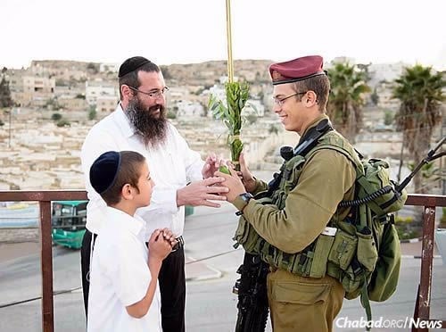

**Rabbi Danny Cohen of Chabad of Hebron and his son Shneor offer the lulav and etrog to a soldier during Sukkot. (Photo: Israel Bardugo)**

On the first day of Sukkot (or the first time on Sukkot you get to do this), add this blessing:

Bah-rookh ah-tah ah-doh-noi eh-loh-hay-noo meh-lekh hah-oh-lahm sheh-heh-kheh-yah-noo veh-kee-mah-noo ve-hig-ee-yah-noo liz-mahn hah-zeh.

*Blessed are You, L‑rd our G‑d, King of the Universe, who has granted us life, sustained us and enabled us to reach this occasion.*

Bring the *lulav* and *etrog* together in your hands and [wave them gently in all six directions](https://www.chabad.org/library/article_cdo/aid/210033/jewish/Pictorial-Guide.htm): right, left, forward, up, down and backward.

The sages of the Midrash tell us that the Four Kinds represent the [various personalities](https://www.chabad.org/holidays/JewishNewYear/template_cdo/aid/3111/jewish/It-Takes-All-Kinds.htm) that comprise the community of Israel, [whose intrinsic unity](https://www.chabad.org/holidays/JewishNewYear/template_cdo/aid/5045/jewish/Unity-in-Three-Dimensions.htm) we emphasize on Sukkot.

**Candles**

Shabbat and holidays are ushered in with candle lighting.

The first two days (one day in Israel) are classified as [*yom tov*](https://www.chabad.org/holidays/JewishNewYear/template_cdo/aid/708530/jewish/Laws-of-Yom-Tov.htm). Like Shabbat, no work is done, with the notable exception that certain types of food prep and carrying in the public domain are permitted.

On these days, the night meals are preceded by holiday candle-lighting in the Sukkah. Before lighting the candles (on the second night, this is done from a pre-existing flame), say:

Bah-rookh ah-tah ah-doh-noi eh-loh-hay-noo meh-lekh hah-oh-lahm ah-sher ki-deh-shah-noo beh-mitz-voh-tahv veh-tzee-vah-noo leh-hahd-lik nayr shehl (shah-baht veh-shehl) yohm tohv.

Bah-rookh ah-tah ah-doh-noi eh-loh-hay-noo meh-lekh hah-oh-lahm sheh-heh-kheh-yah-noo veh-kee-mah-noo ve-hig-ee-yah-noo liz-mahn hah-zeh.

*Blessed are You, L‑rd our G‑d, King of the Universe, who has sanctified us with His commandments and* *has commanded us to kindle the light of (Shabbat and of ) the Festival Day*.

*Blessed are You, L‑rd our G‑d, King of the Universe, who has granted us life, sustained us and enabled us to reach this occasion.*

If it is rainy or windy in the *sukkah*, and you cannot protect the candles from the elements, of if they pose a fire hazard in the *sukkah*, they may be lit indoors.

**Festive Meals**

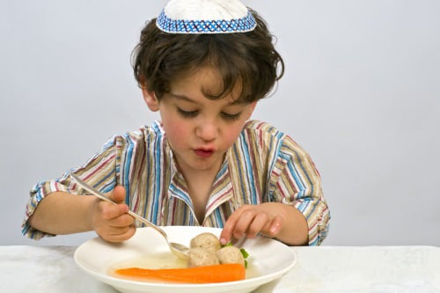

The festive meals we eat in the *sukkah* are preceded by [Kiddush](https://www.chabad.org/library/article_cdo/aid/484181/jewish/What-Are-the-Kiddush-basics.htm) over wine, and we then begin the meal over two whole loaves of [challah](https://www.chabad.org/theJewishWoman/article_cdo/aid/323423/jewish/Taking-Challah.htm), which are sliced, dipped in honey and distributed to all those present. Before we eat we say the special *sukkah* blessing, and the Grace After Meals includes special holiday insertions.

Like all holiday meals, it is appropriate to pepper the conversation with words of Torah and inspiration, as well as Jewish songs.

(Read more here: [What to Expect at Sukkot Meals](https://www.chabad.org/library/article_cdo/aid/3012340/jewish/What-to-Expect-at-a-Sukkot-Meal-in-a-Sukkah.htm))

**Hoshanot and** [**Hoshanah Rabbah**](https://www.chabad.org/library/article_cdo/aid/757453/jewish/Hoshana-Rabbah.htm)

Every day of Sukkot, we say Hallel, the psalms of praise from [Psalms](https://www.chabad.org/library/bible_cdo/aid/15770/jewish/Tehillim-Psalms.htm) (113-118) as part of the morning prayer service. Every day besides Shabbat, we do so clutching the Four Kinds, waving them in all directions at certain key points in the service outlined in the *siddur* (prayerbook).

Afterward, we circle the [*bimah*](https://www.chabad.org/library/article_cdo/aid/365934/jewish/The-Bimah-The-Synagogue-Platform.htm) (the podium on which the [Torah](https://www.chabad.org/library/article_cdo/aid/1426382/jewish/Torah.htm) is read) holding the Four Kinds, reciting alphabetically arranged prayers for Divine assistance known as Hoshanot.

The seventh day of the holiday is known as Hoshanah Rabbah. This is the day when our fates for the coming year—which were signed on Rosh Hashanah and sealed on [Yom Kippur](https://www.chabad.org/library/article_cdo/aid/4687/jewish/Yom-Kippur-2025.htm)—are finalized. On this day, we circle the *bimah* seven times. We also say a short prayer and strike the ground five times with bundles of five willows (also known as Hoshanot)

On Sukkot, G‑d determines how much rain will fall that winter (the rainy season in Israel). Thus while every sacrifice in the Temple included wine libations poured over the altar, on Sukkot, water was also poured over the altar in a special ceremony. This ritual engendered such joy that it was celebrated with music, dancing and singing all night long. This celebration was called was “Simchat Beit Hasho’evah.”

Even today, when there is no Temple, it is customary to hold nightly celebrations that include singing and dancing (and even live music during the intermediate days of the holiday).

[**Shemini Atzeret**](https://www.chabad.org/library/article_cdo/aid/1288672/jewish/How-to-Celebrate-Shemini-Atzeret.htm) / [**Simchat Torah**](https://www.chabad.org/library/article_cdo/aid/4583/jewish/How-to-Celebrate-Simchat-Torah.htm): Even More Joy

The Torah tells us that after the seven days of Sukkot, we should celebrate an eighth day. In the diaspora, this eighth day is doubled, making two days of *yom tov*, when candles are lit and no work is done. On the final day, it is customary to conclude and then immediately begin the annual cycle of Torah reading, making this day Simchat Torah (“Torah Celebration”).

Although the eighth day follows Sukkot, it is actually an independent holiday in many respects (we no longer take the Four Kinds or dwell in the *sukkah*). Diaspora Jews eat in the *sukkah,* but without saying the accompanying blessing (there are some who eat just some of their meals in the *sukkah* on the eighth day).

The highlight of this holiday is the boisterous singing and dancing in the synagogue, as the Torah scrolls are paraded in circles around the *bimah*.

(Read more here: [What to Expect at Simchat Torah](https://www.chabad.org/library/article_cdo/aid/3076430/jewish/What-to-Expect-at-Simchat-Torah-Services.htm))

**Final Note**

By the time Simchat Torah is over, we have experienced a spiritual roller coaster, from the solemn introspection of the High Holidays to the giddy joy of Sukkot and Simchat Torah. Now it is time to convert the roller coaster into a locomotive, making sure that the inspiration of the holiday season propels us to greater growth, learning and devotion in the year ahead.

*Reprinted from the current website of Chabad.Org*

**Rav Avigdor Miller on Sukkos:**

**The Finale of the Yomim Noraim**

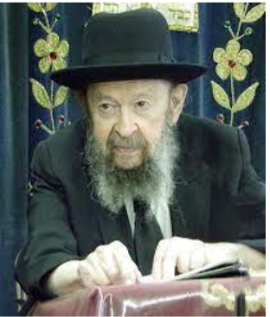

**QUESTION:** Is there a connection between Yom Kippur and Sukkos?

**ANSWER:** The answer is that there is an obvious connection.  Rosh Hashana and Yom Kippur are occasions of proclaiming the*malchus Hashem*. It’s המלך הקדוש and  ותמלוך אתה all day long. The entire *tefillos*of Rosh Hashana and Yom Kippur are permeated with the concept of Melech.

Now, once we establish in our minds the awareness that השם מלך, then it follows that Hakodosh Boruch Hu is in charge; He supervises.  Hashgacha, providence; everything is under the control of Hashem.

And that is exactly what Sukkos is telling us.  כי בסוכות הושבתי את בני ישראל בהוציאי אותם מארץ מצרים – *I* *caused them to dwell in Sukkos when I took them out of Egypt.*  They did not have walled cities with permanent strong buildings. They dwelled in tents, in tabernacles, in flimsy edifices that were no protection against invaders. They were at that time the most unprotected in all of their history.

And yet, never in history subsequently were they as secure as they were in the Midbar.  Never again did they have such guarantee for their safety as they had in these little flimsy *sukkos*. How could that be if they had no walls, no brick homes?

**Only the Glory of Hashem**

And the answer is the *schach*. The *schach*symbolizes that there’s nothing on top of you to protect you, only the glory of Hashem.  It was Hashem’s especial providence that caused them to be more secure in the wilderness than even later when they had walled cities.

And that’s the lesson of Sukkos, that we live always in the*sukkas shloimecha*; we live in the protection of Hashem.

Even now, although we are not as secure as our forefathers were – we don’t have the same amount of *hashgacha* to protect us – but Hakodosh Boruch Hu is still with us today as always.  Only that in those days, it was most evident.  The Shechina was overhead, the*ananei hakavod*, and the purpose was to teach the people a lesson for all generations, that even when there won’t be*ananei hakavod,*we have to remember that Hakodosh Boruch Hu still hovers over His people.

**The Eternity of Am Yisroel**

All other nations in the course of time fall and are swallowed up by the earth, but the Am Yisroel will continue forever.  No matter how weak we seem to be, we should always be reminded that we are the strongest of nations because Hakodosh Boruch Hu is with us.

And therefore, the *sukkah*is a corollary of*malchus Hashem*. Sukkos is the *bitachon*, the *emunah*, the confidence which comes from the awareness of Hashem our King. And that awareness, of course, is what we learn by the *avodah*of Rosh Hashana and Yom Kippur.

*Reprinted from aN email of Torah Avigdor based on a lecture delivered on. October 14, 1983 (Tape #476).*

**The Wizard of Oz**

**and the Jews**

**By Dr. Yvette Alt Miller**

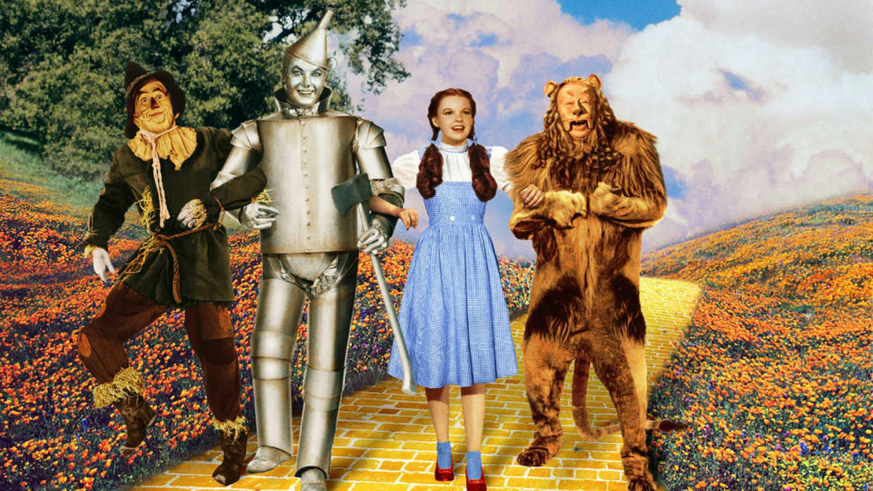

**Behind the magic of The Wizard of Oz lies a story of Jewish pain, hope, and creativity—from its antisemitic author to the Jewish artists who transformed it into an immortal anthem of longing for home.**

Visitors to Las Vegas are raving about The Wizard of Oz at the Sphere, an immersive experience that reimagines the beloved film with cutting-edge special effects—a life-size tornado, flying objects, and a fresh soundtrack. “Who hasn’t wanted to walk down that Yellow Brick Road themselves?” asks Oscar-nominated producer Jane Rosenthal, who helped bring this dazzling new version to life.

Her latest project introduces The Wizard of Oz to a new generation of theatre-goers, some of whom may be surprised to learn that the film was created largely by Jewish artists—and is infused with Jewish themes.

**Creating The Wizard of Oz—and Hating Jews**

Journalist and writer L. Frank Baum published The Wonderful Wizard of Oz in 1900, followed by 13 sequels. Although billed as fantastical tales for children, historians note that Baum’s work reflected the politics of the 19th-century Populist movement.

Scholar Henry Littlefield argued that the story served as an allegory for the era’s bitter battles between “Gold bugs,” who supported the Gold Standard, and “Silverites,” who advocated backing U.S. currency with both silver and gold. Westerners like Baum, who lived in South Dakota, supported the latter. In Baum’s original books, Dorothy’s slippers are silver, and she walks a gold path toward a Washington-like city ruled by a befuddled leader. The Tinman represents factory workers; the Scarecrow stands in for downtrodden farmers; and the Cowardly Lion is widely seen as William Jennings Bryan, a politician who championed farmers and the lower classes.

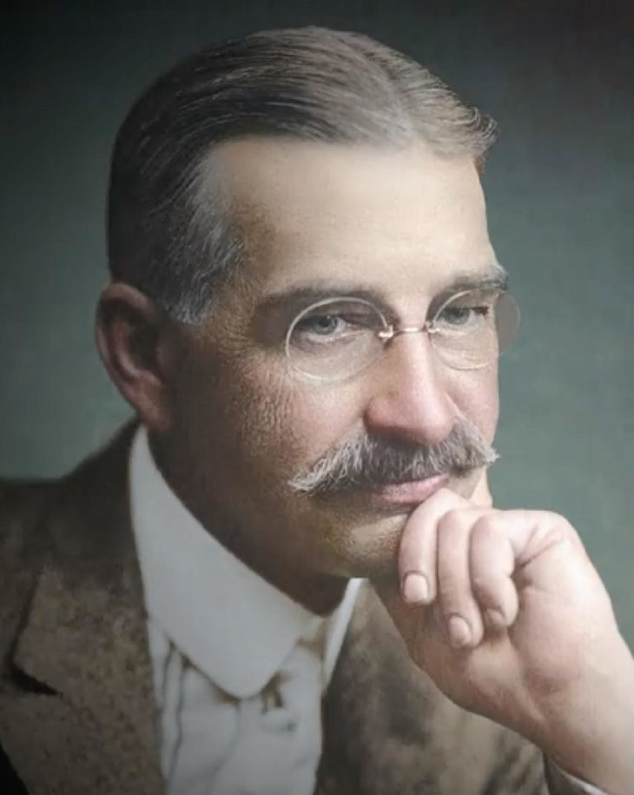

**L. Frank Baum**

Baum himself insisted the book was “pure inspiration.” (That same year he also published The Art of Decorating Dry Goods Windows and Interiors—a far less popular work.) In a 1939 [interview](https://lithub.com/l-frank-baums-literary-vision-of-an-american-century-the-wizard-of-oz-at-125-years/), Baum suggested he had received inspiration from a Higher Being while writing Oz.

This idea fit with Baum’s eccentric religious leanings. He and his wife Maude converted from Methodism to Theosophy, an occult movement founded by Russian mystic Helena Blavatsky. Blavatsky’s writings were steeped in antisemitism, portraying Jews as “semi-human” and describing Judaism as a “religion of hate and malice.”

Even before embracing Theosophy, Baum displayed virulent prejudice. As editor of the Saturday Pioneer newspaper in Aberdeen, South Dakota, in 1890, he called for the “annihilation” of Native Americans, writing after the massacre at Wounded Knee: “Wipe these untamed and untamable creatures off the face of the earth.” Even by the standards of his time, Baum’s racism was extreme. (In 2006, his descendants formally apologized to the Sioux people.)

Not surprisingly, elements of these views seeped into Baum’s Oz books. Over the years, publishers removed the most offensive passages, leaving the sanitized versions familiar to modern readers.

**Jewish Artists Create The Wizard of Oz**

Despite Baum’s antisemitism, the Oz series became a runaway success, selling millions of copies. In the 1930s, Metro-Goldwyn-Mayer adapted it into a Hollywood blockbuster—crafted largely by Jewish talent.

Composer Harold Arlen (born Hyman Arluck in Buffalo, 1905) grew up in a devout Jewish family; his father was a cantor, and young Arlen sang in synagogue. He went on to write the film’s unforgettable score, including the Academy Award–winning “Somewhere Over the Rainbow.”

Lyricist E.Y. “Yip” Harburg (born Isadore Hochberg) was the son of Russian Jewish immigrants on New York’s Lower East Side. After losing everything in the 1929 crash, he turned his passion for lyrics into a career—encouraged by his friend Ira Gershwin. Harburg, always socially progressive, later faced blacklisting during the McCarthy era. Among his earlier hits was the Great Depression anthem “Brother, Can You Spare a Dime?”

The screenplay was created by a largely Jewish group of writers: Herman Mankiewicz grew up in an observant Jewish household in New York City and worked as a journalist, including for a Jewish newspaper, before turning to screenwriting. He was an outspoken critic of Nazism both in his journalism and in his screen work.

Irving Brecher grew up in a Jewish home in the Bronx and wrote for the Marx Brothers before joining the Wizard of Oz team.  Herbert Fields came from a prominent Jewish songwriting family; his father was the famous vaudeville performer Lew Fields (born Moses Schoenfeld).  Samuel Hoffenstein was born in Odessa and moved to the United States, where he became a popular film writer and poet.

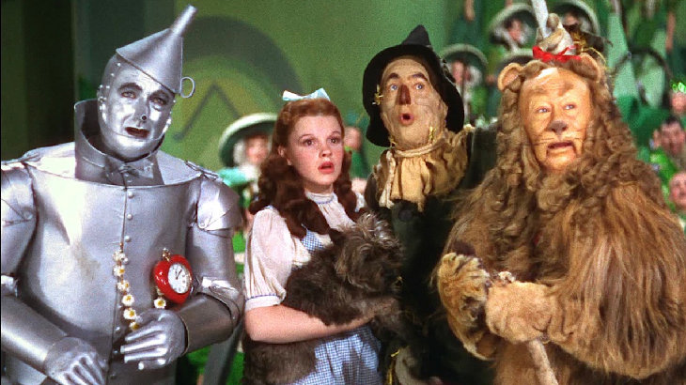

Perhaps the most recognizable Jewish figure in the film was Bert Lahr (born Irving Lahrheim), who played the Cowardly Lion. Raised in a loving Jewish home in New York, Lahr became a beloved comedian whose trademark Brooklyn accent added charm to the role.

**Longing for Home—Somewhere Over the Rainbow**

The film’s emotional power came in part from the deep anxieties its Jewish creators were experiencing. The Wizard of Oz premiered on August 25, 1939—just days before Nazi Germany invaded Poland. As Arlen, Harburg, Mankiewicz, and others labored on the film, they watched in anguish as relatives in Europe faced persecution and being attacked during Kristallnacht. Their work channeled both desperation and hope, lending the film an enduring resonance.

Dorothy’s desperate attempts to escape the Wicked Witch of the West mirrored the plight of Jewish families trapped in Europe. Her longing to return “home” echoed Jewish liturgy and the yearning to return to the Land of Israel.

The song Somewhere Over the Rainbow carried particular Jewish resonance. Its poignant line “a land that I heard of once in a lullaby” is thought to draw inspiration from Rozhinkes mit Mandlen (“Raisins and Almonds”), a famous Yiddish lullaby written by Abraham Goldfaden in 1881. That haunting song, describing a mother rocking her child while foretelling hardship and exile, urged Jews never to forget their homeland. The parallel is striking—and moving.

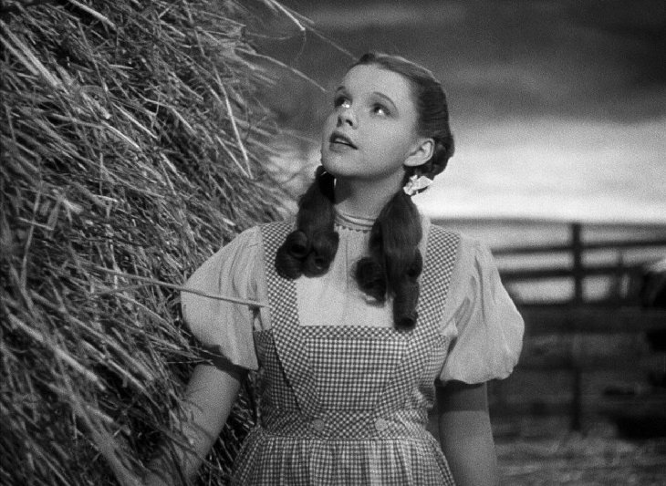

**Relevance Today**

The promise of finding safety, home, and goodness resonates as powerfully today as it did in 1939. In 2014, the Jewish singer Pink performed [Somewhere Over the Rainbow](https://savethemusic.com/video/the-jewish-roots-of-somewhere-over-the-rainbow/) at the Oscars. Her mother, Judith Kugel, later reflected that the song captured the longing of its Jewish creators during the rise of Nazism:

“I wasn’t thinking about the movie,” she recalled, “I was thinking about the lost Jews of Europe and the immigrants in the United States, and celebrating our struggle for survival in every community and every country where we live, always with the idea of bringing something better to this world.”

With the reimagining of The Wizard of Oz at the Sphere, a new generation is being introduced not only to a classic film, but also to its profound Jewish legacy.

*Reprinted from the current website of aish.com*

**Know Your Worth**

**By Rabbi Joey Haber**

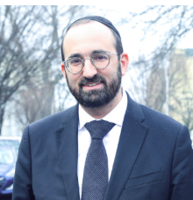

I once witnessed the following scene in a busy shul in Brookyln with lots of minyanim.

A young man approached someone to ask for tzedakah, explaining that he was getting married and needed help.

The man handed him his credit card and told him to charge $52.

Just then, someone else passed by, and this fellow asked him if he could help. The guy pulled out a $1 bill and handed it to him. He said, "Thank you."

He then turned to the first fellow, who had given him his card, and said, "Look, I need a pair of nice shoes for the wedding. Maybe you can give a little more?"

At first I was astonished. That second guy gave him $1 and got a "thank you," but the first, who offered him $52, got a request for more. How could that be?

Very quickly, though, I understood why this happened.

The "$1 guy" isn't going to do much more, but the "$52 guy" is capable of more. Someone who gave just one dollar cannot be expected to give anything beyond that, but someone who is able and willing to give $52 is likely to be able and willing to give even more than that.

Sure enough, the first guy told the fellow to charge the card for an additional $50.

I believe this is the mistake that so many of us make – especially this time of year – which hinders our growth, which stops us from becoming better.

We all see ourselves as pretty good people, or even very good people – and we are right. We are good people. The problem is that although we give $52, we want to be left alone like the guy who gave $1. Specifically, because we feel good about who we are – as we certainly should!!! – we feel that it's enough, that we don't need to try any harder.

I imagine that if I had accomplished by the age of 20 all that Rav Ovadia Yosef zt"l accomplished by that age, I would feel pretty content. He was already an outstanding scholar who had mastered pretty much all of Torah. But he was not content. Not at all. He went on to not only write dozens of important books of halachah and answer untold numbers of halachic questions, but to devote himself tirelessly to the Jewish People, uplifting the entirety of Sephardic Jewry. He didn't think what he accomplished was enough – because he knew how much more he could do, and he was prepared to work as hard as was necessary to do it.

The story is told of a man who bought his son an antique car for his college graduation. He told him to go find out how much the car was worth.

The son came back and told his father that he brought the car to a dealership, and they said that it could hardly drive. It was worth at most $500.

"Bring it to a pawn shop," the father instructed.

The boy came back and reported that the guy at the pawn shop said it might be worth as much as $1000.

The father then told his son to bring the car to a classic car club.

The owners of the club were so excited by the car. They offered the young man $100,000 for it.

"This is the lesson I want you to learn," the father said. "Some people will see how much value you have, other people won't. Always know just how valuable you are."

Our problem is that we don't know our value. We see ourselves as $52 people, and so this is all we give. We need to understand that we have so much more to give, so much more to contribute, and so much more to achieve.

We were not brought to this world to be just ok. We were brought here to be everything we are capable of being.

*Reprinted from the Parashat Vayelech-Yom Kippur 5786 email of Rabbi David Bibi’s Shabbat Shalom from Cyberspace.*